Lab-3

Name: Vishnu Praveen Gude

NO: 16103389

1.Mashup APP(Google Voice AND Weather):

1.I created a image button for speech intent window.

2.when user clicks that button speech intent will popup so that user can say city name .

3.It is stored to the variable and displayed as text.

4.That city name is passed to openweathermap.org url

5.then the json output is parsed using json library and returns the string values of temp and temp_max fields.

6.Then the values is displayed to text view.







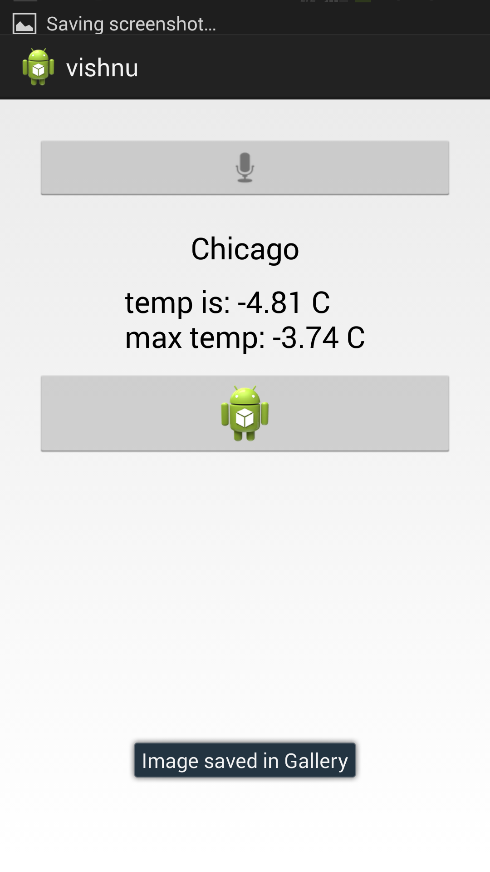

2.HADOOP/MAP REDUCE

a.I installed VMWare and cloudera image.

b.I went to cloudera image and downloaded word count zip folder.

c.I placed input folder to Hadoop directory

hadoop fs –put input input

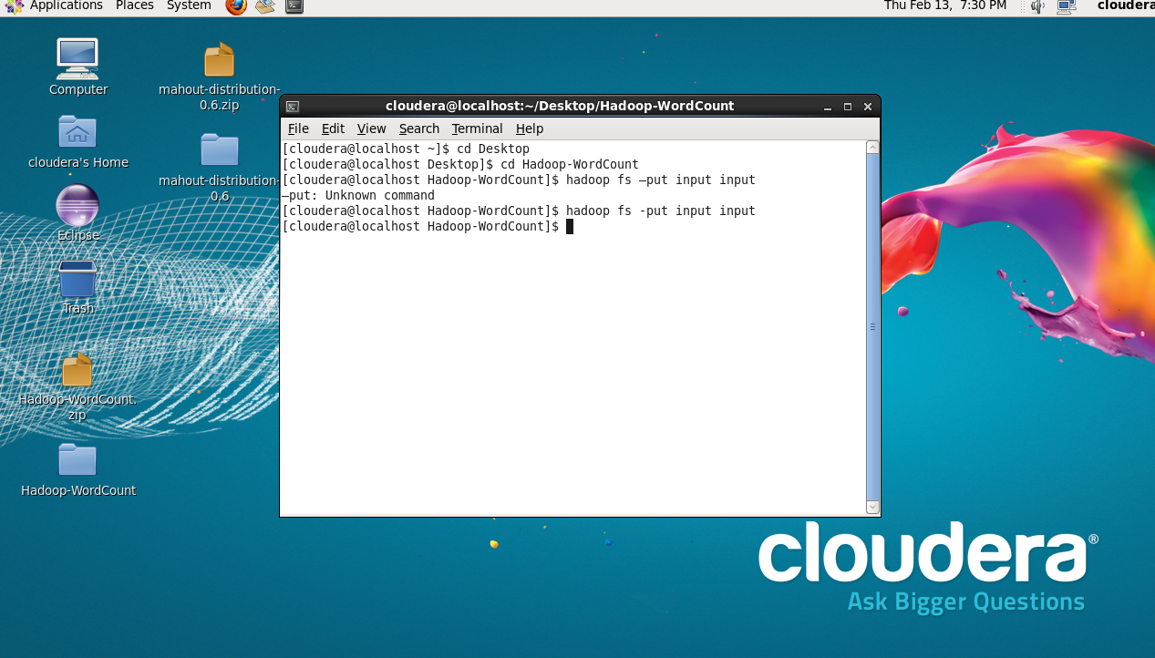

d.Then run Hadoop using

hadoop jar wordcount.jar WordCount input output1

e.view the result

hadoop fs -cat output1/*

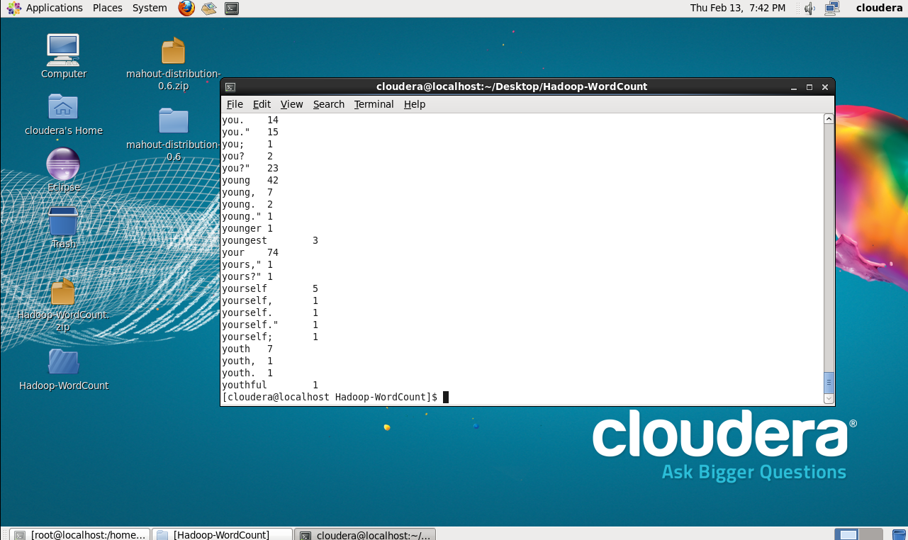

3.Hadoop/Mahout

a.I downloaded maven

*wget* [*http://www.apache.org/dist//maven/binaries/apache-maven-3.0.5-bin.tar.gz*](http://www.apache.org/dist//maven/binaries/apache-maven-3.0.5-bin.tar.gz)

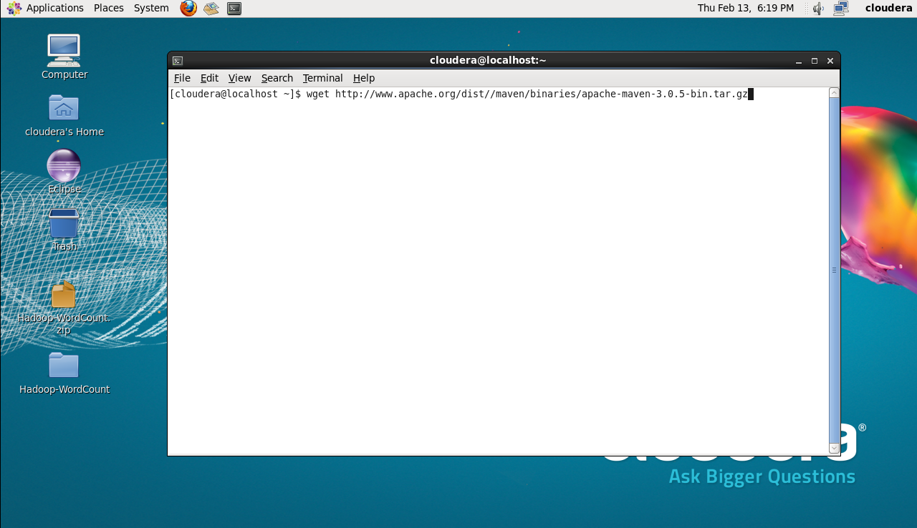

Extracting zipped folder

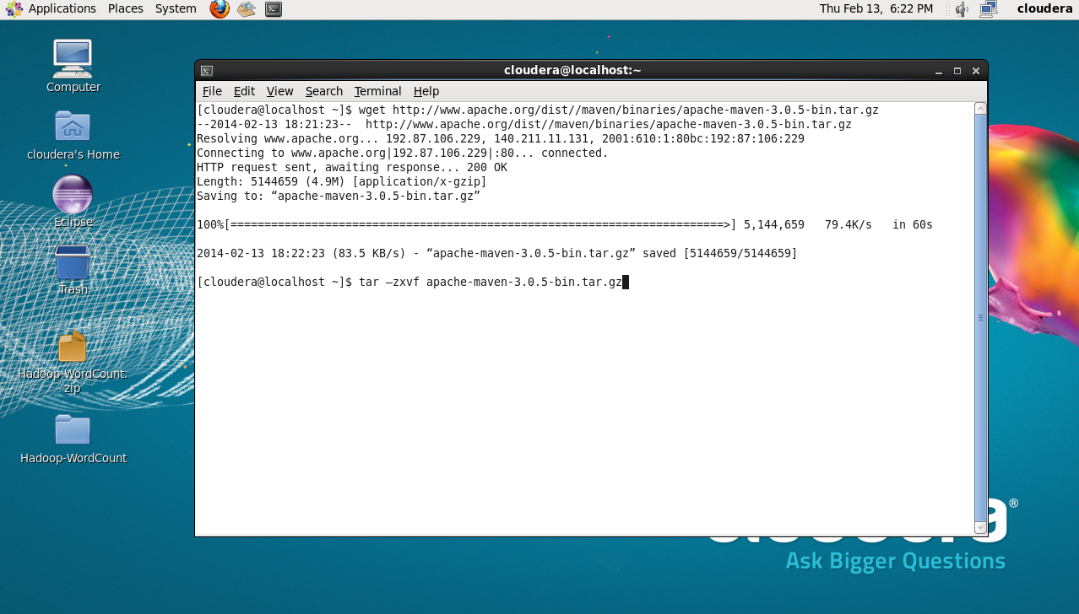

Adding M2_HOME and PATH

*export M2_HOME=/home/cloudera/apache-maven-3.0.5*

*export PATH=${M2_HOME}/bin:${PATH}*

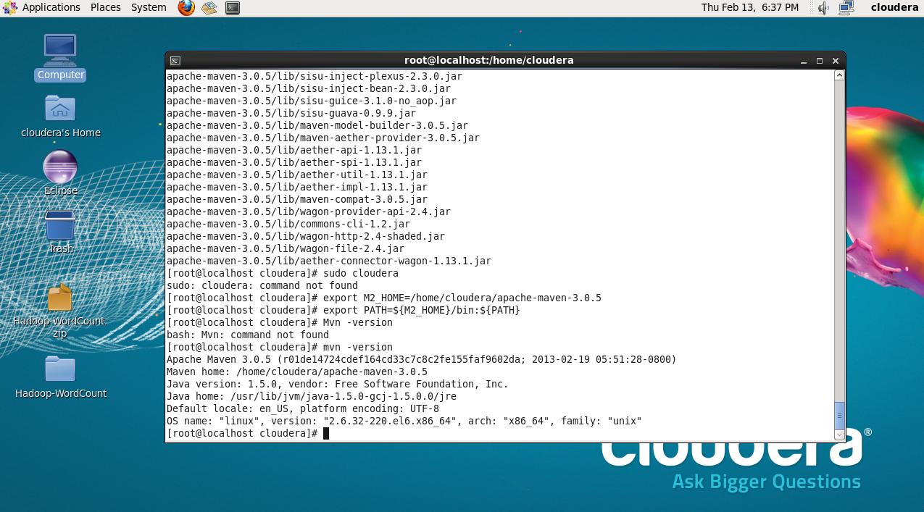

Then I downloaded mahout distribution 0.6 and pom file and placed pom file in mahout distribution folder

Then I set java path

export JAVA_HOME=/usr/java/jdk1.6.0_32/

Then,Installing mahout using pom file

mvn –f mahout-distribution-0.6.pom -DskipTests install

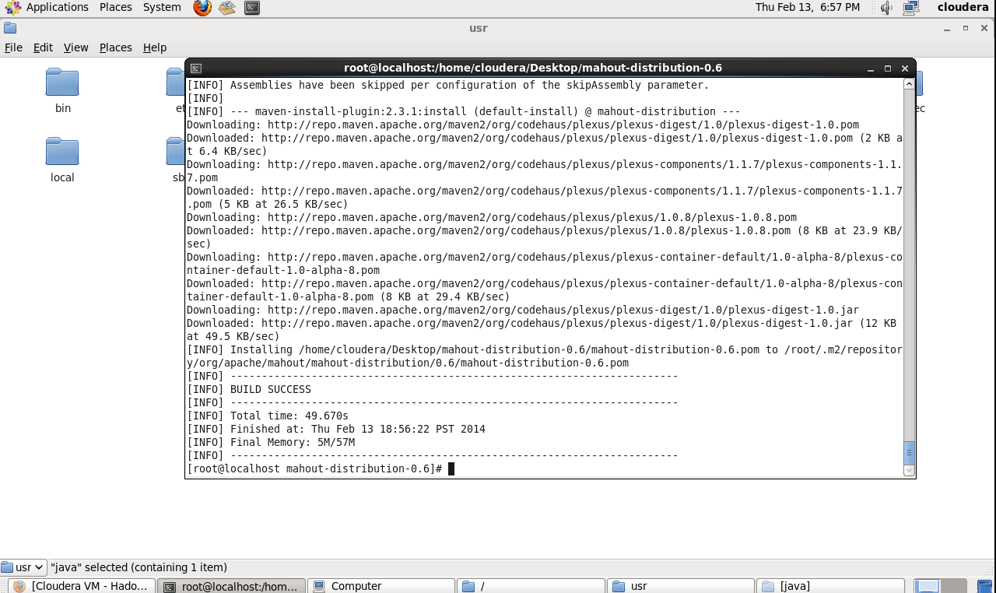

Then I went to examples folder then went to bin

I run sh file to classify 20 news groups

./classify-20newsgroup.sh

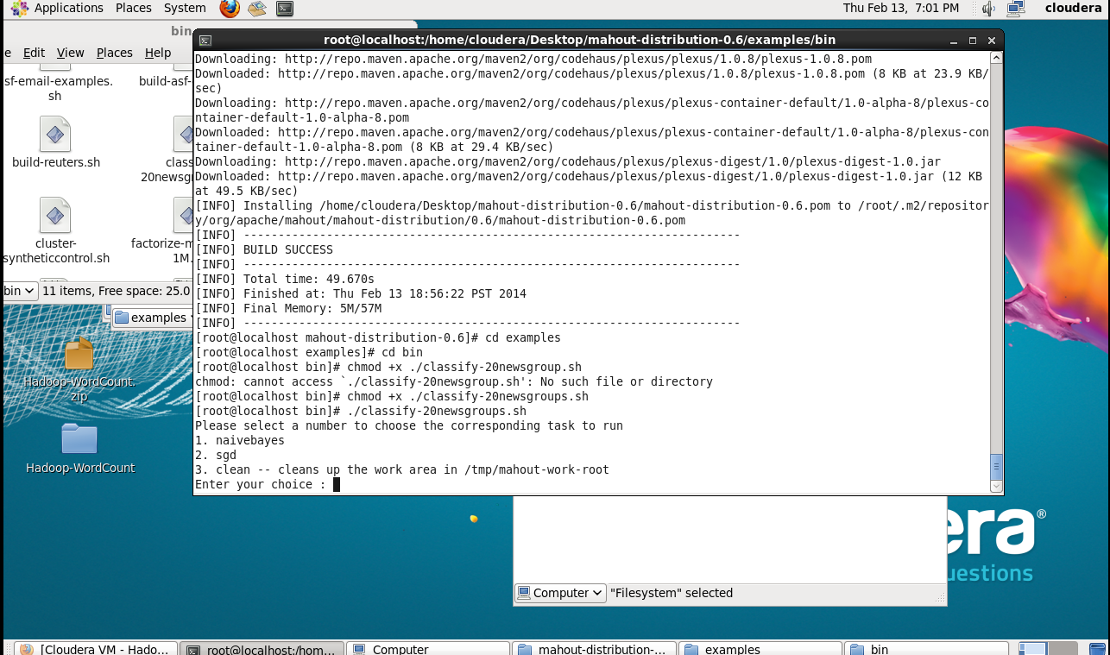

Then I selected naivebayes algorithm to classify news groups

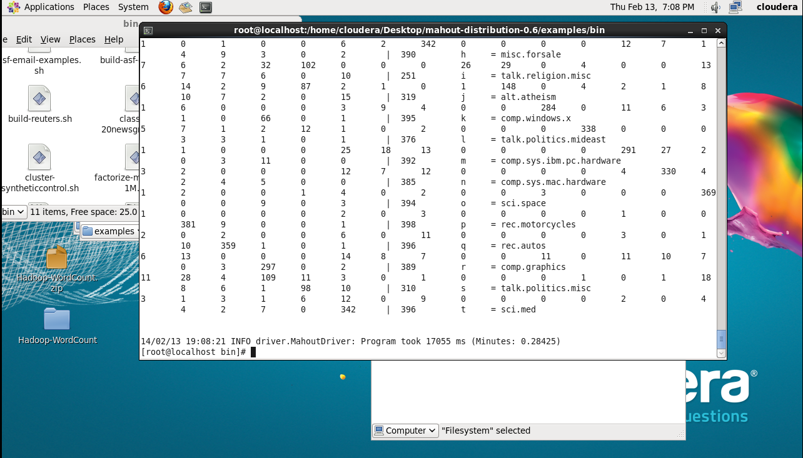

Thus I used mahout for the classification of news groups.